-Assignment 1: Snowflake Environment Setup (Beginner)
Objective: Understand Snowflake UI and basic objects.
Tasks
1.Log in to Snowflake (trial account).
Create a Database
create database new_roles;
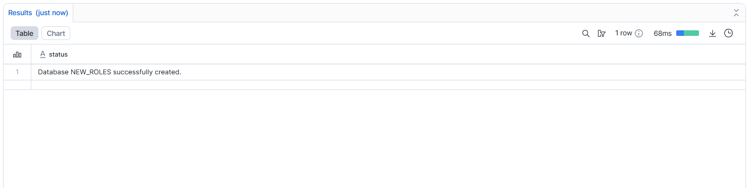
Create a Schema
create schema sch_roles;
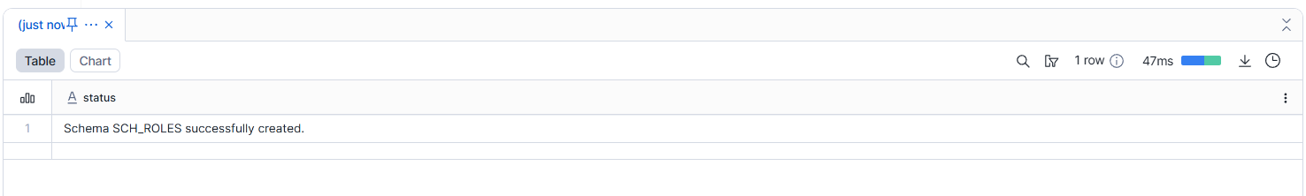
Create a Virtual Warehouse
Create warehouse my_wh
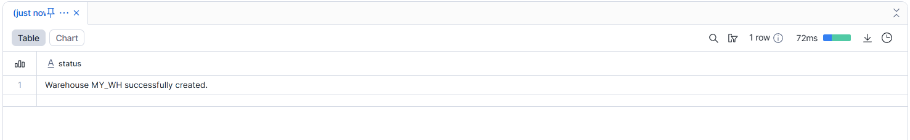
2.Show all databases and schemas.
Show databases;
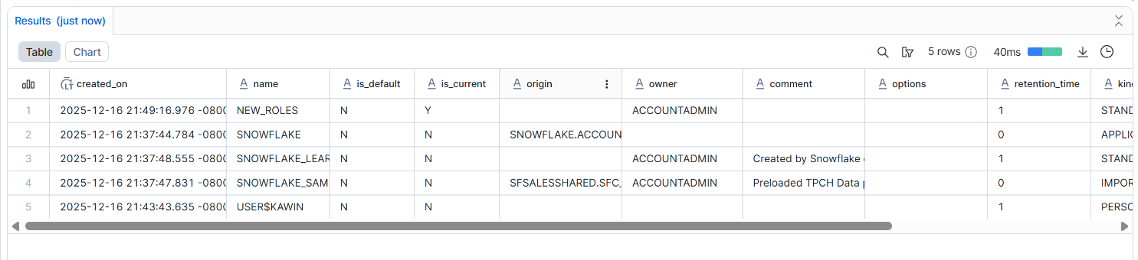
Show schemas;
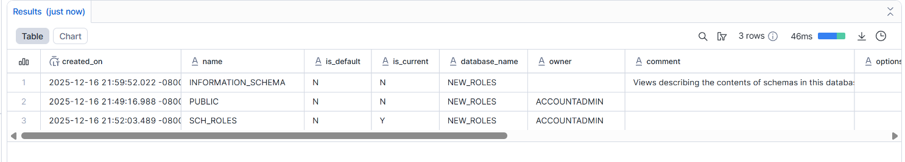
3.Suspend and resume the warehouse.
Alter warehouse my_wh suspend;
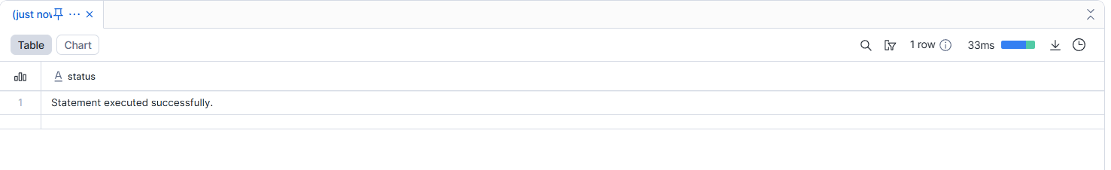
Alter warehouse my_wh resume;
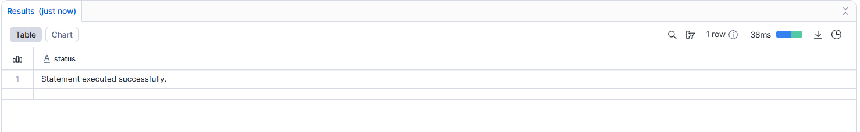

Deliverable:
- SQL script
- Screenshot of created objects
----------------------------------------------------------------------------------------------------------------------------------------------------------------------------------------------------------------------------------------------------------------------------
Assignment 2: User, Role & Access Control (RBAC)
Objective: Learn Snowflake security and role hierarchy.
Tasks
1.Create roles:
create or replace role STUDENT_ROLE;
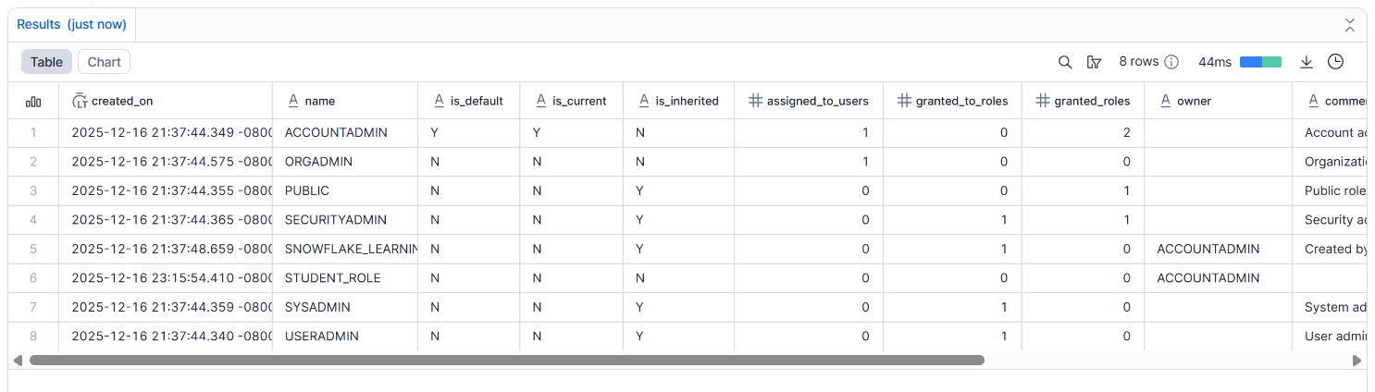
Create or replace role INSTRUCTOR_ROLE;
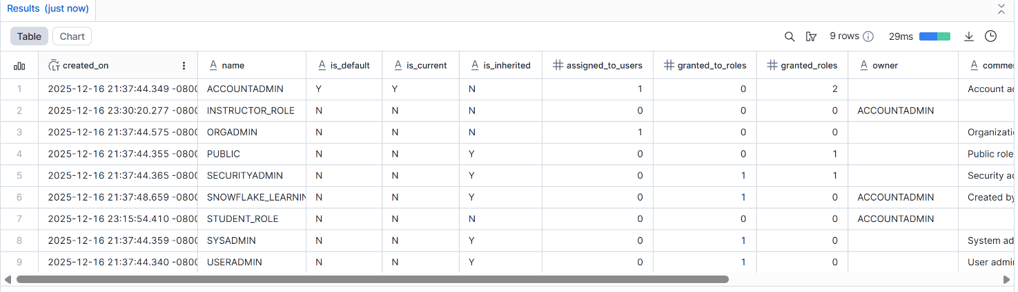
INSTRUCTOR_ROLE
- Create users:
Create users student1
CREATE USER student1
PASSWORD = 'Student@123'
DEFAULT_ROLE = STUDENT_ROLE
MUST_CHANGE_PASSWORD = TRUE;
Create users instructor1
CREATE USER instructor1
PASSWORD = 'Instructor@123'
DEFAULT_ROLE = INSTRUCTOR_ROLE
MUST_CHANGE_PASSWORD = TRUE;
- Assign:
STUDENT_ROLE → student1
GRANT ROLE STUDENT_ROLE TO USER student1;

INSTRUCTOR_ROLE → instructor1
GRANT ROLE INSTRUCTOR_ROLE TO USER instructor1;
- Grant permissions:
Student → SELECT on tables
GRANT SELECT
ON ALL TABLES IN SCHEMA new_roles.sch_roles
TO ROLE STUDENT_ROLE;
Instructor → SELECT, INSERT
GRANT SELECT, INSERT
ON ALL TABLES IN SCHEMA new_roles.sch_roles
TO ROLE INSTRUCTOR_ROLE;
- Verify access using SHOW GRANTS.
SHOW GRANTS TO USER student1;
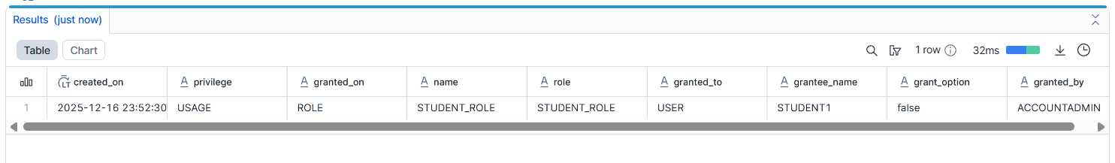
SHOW GRANTS TO USER instructor1;
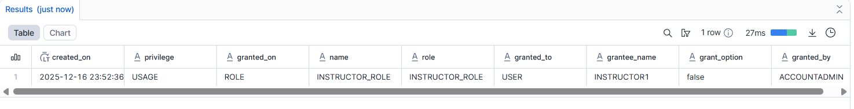
SHOW GRANTS TO ROLE STUDENT_ROLE;
SHOW GRANTS TO ROLE INSTRUCTOR_ROLE;
Deliverable:
- SQL commands
- Short explanation of RBAC

----------------------------------------------------------------------------------------------------------------------------------------------------------------------------------------------------------------------------------------------------------------------------

Assignment 3: Table Creation & Data Loading
Objective: Work with structured data.
Tasks
1.Create a table:
CREATE TABLE students (
id INT,
name STRING,
course STRING,
score INT
);
2.Insert at least 10 records.
INSERT INTO students VALUES
(1, 'Amit', 'Math', 85),
(2, 'Priya', 'Science', 78),
(3, 'Rahul', 'Math', 92),
(4, 'Sneha', 'English', 88),
(5, 'Arjun', 'Science', 65),
(6, 'Kavya', 'Math', 90),
(7, 'Rohan', 'English', 72),
(8, 'Neha', 'Science', 81),
(9, 'Vikram', 'Math', 95),
(10, 'Anjali', 'English', 84),
(11, 'Suresh', 'Math', 76),
(12, 'Meena', 'Science', 89),
(13, 'Karthik', 'English', 91),
(14, 'Pooja', 'Math', 68),
(15, 'Nitin', 'Science', 83),
(16, 'Divya', 'English', 87),
(17, 'Manoj', 'Math', 79),
(18, 'Ritu', 'Science', 94),
(19, 'Aakash', 'English', 66),
(20, 'Bhavya', 'Math', 88);
- Query:
All students
select * from students
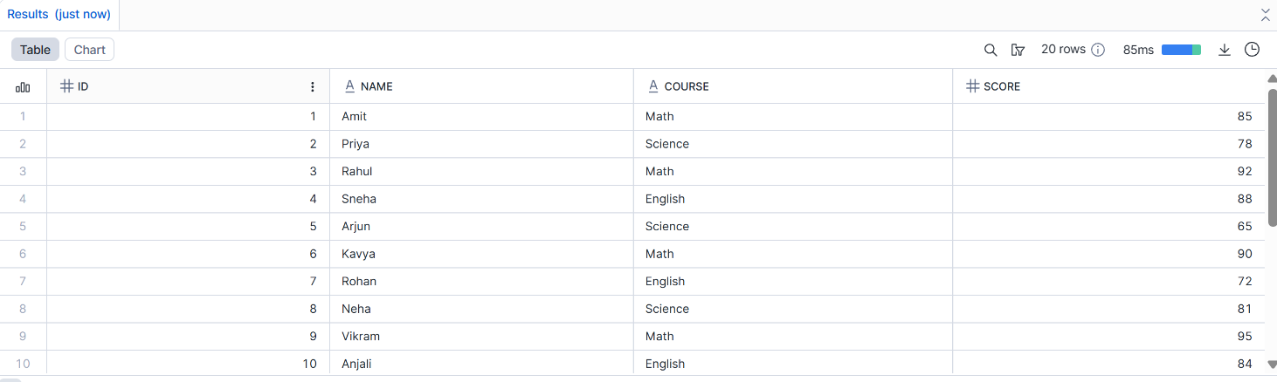
Students with score > 80
select * from students where score > 80;
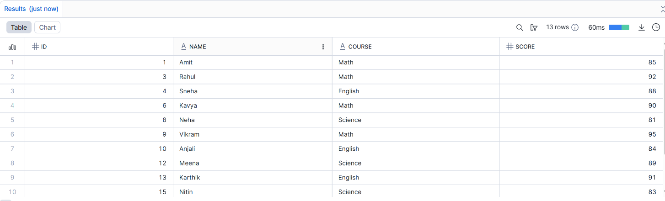
- Update one record.
update students set score = 82 where id = 3;
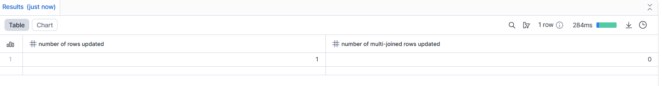
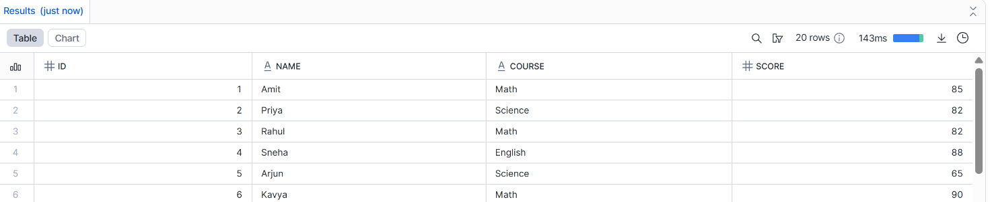

- Delete one record.
DELETE FROM students WHERE id = 5;
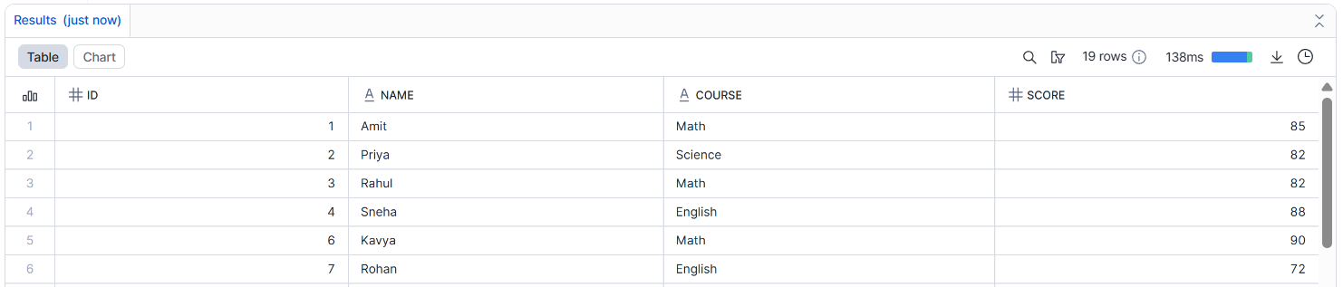
Deliverable:
- SQL file with queries
- Output screenshots
Assignment 4: File Loading using Stage & COPY (Intermediate)
Objective: Learn Snowflake data ingestion.
Tasks
- Create an internal stage.
- Upload a CSV file.
- Use COPY INTO to load data.
SELECT * FROM STUDENT;
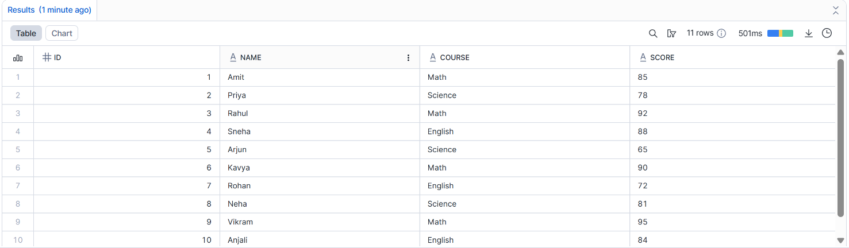
- Validate loaded records.
- Handle one data error using VALIDATION_MODE.
Deliverable:
- SQL script
- CSV file
- Query output
Assignment 5: Time Travel & Data Recovery
Objective: Understand Snowflake Time Travel.
Tasks
- Delete records from a table.
- Query data using Time Travel.
- Restore deleted data.
- Explain how Time Travel helps in recovery.
Deliverable:
- SQL queries
- Short explanation

